Bridgepoint Parts Catalog

Section XXXII: TurboForce and Rug Rat Parts Page 1

PHP6322

Turbine Rug Rat

PHP6332

Brush Rug Rat
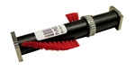

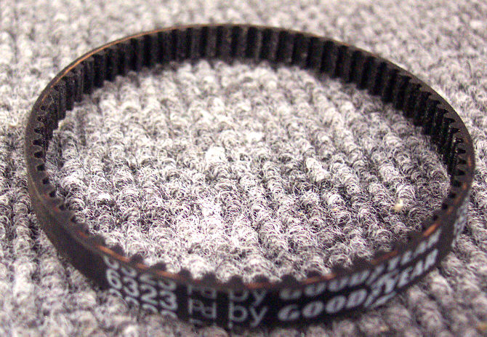

PHP7213

Turbine Turbo Force Vac

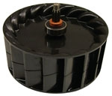

PHP6323-01

Belt Rug Rat

PHP8558

Turbine Turbo Force Zoom Vac

PHP7227-01

Belt TurboForce Vac

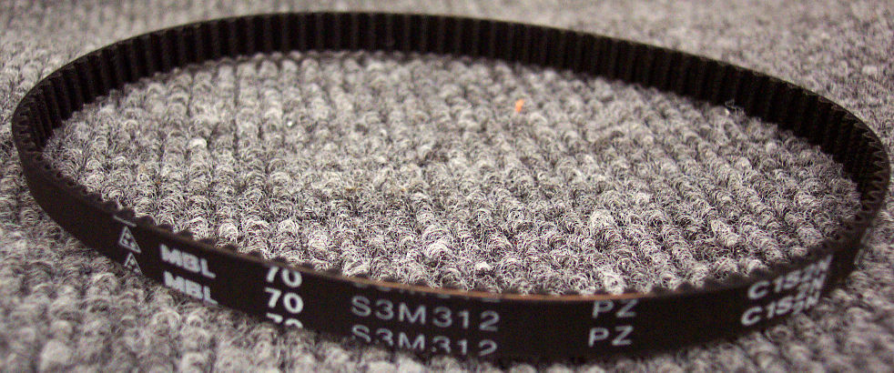

PHP7234

Bearing Turbo Force Vac

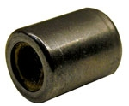

PHP7235

Shaft Turbo Force Vac Brush

PHP7236

Shaft Cap – Turbo Force Vac

PHP7819

Brush Turbo Force Vac

AW18

Elbow Black Plastic

Turbo Force Vac
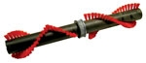
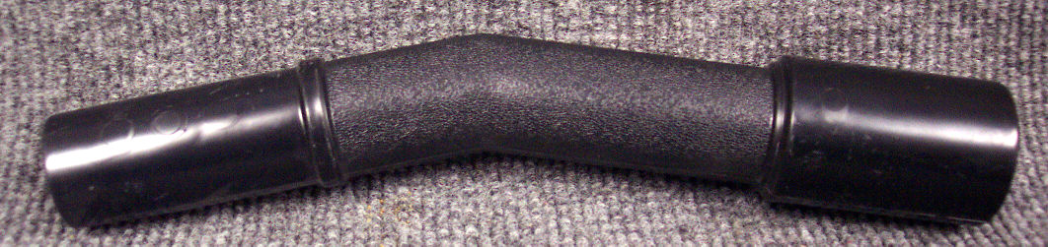

PHP8439-01

Belt Turbo Zoom Vac
Sold in pack of three belts

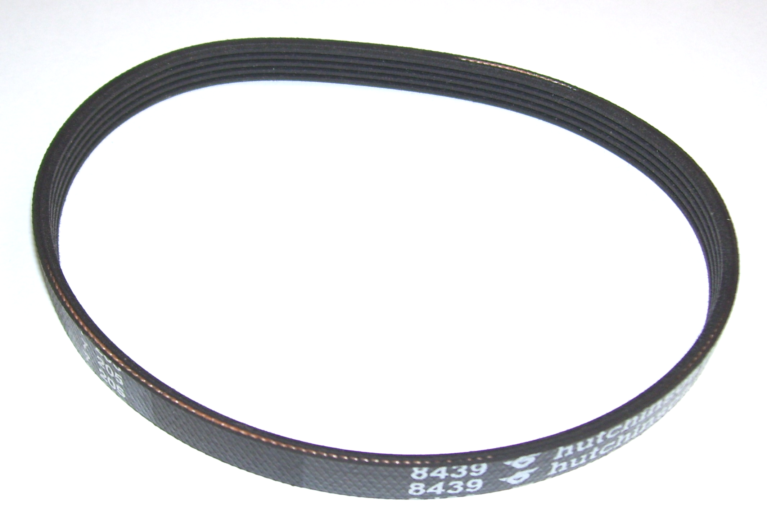

AW35

Extension 1-1/4” x 20”

TurboForce Vac

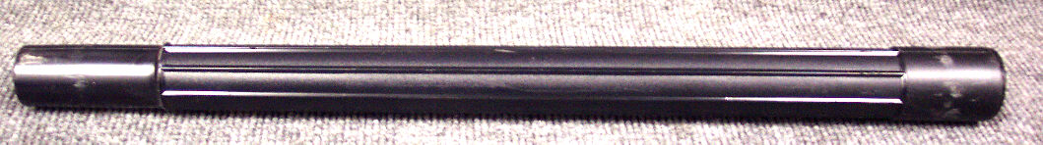

PU917L

Belt Hydrovac

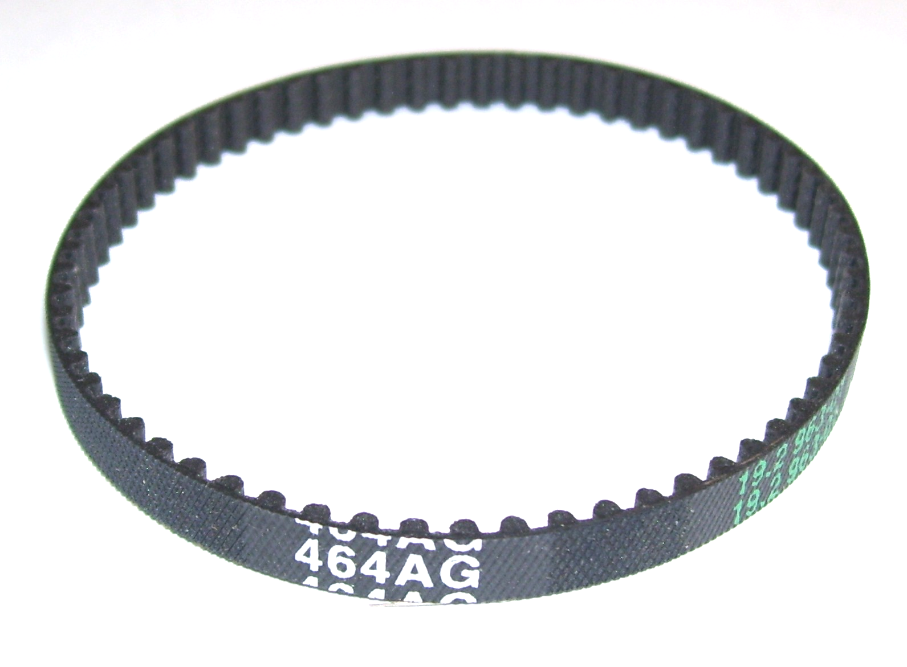

AW36

Power Head Only

Turbo Force Vac
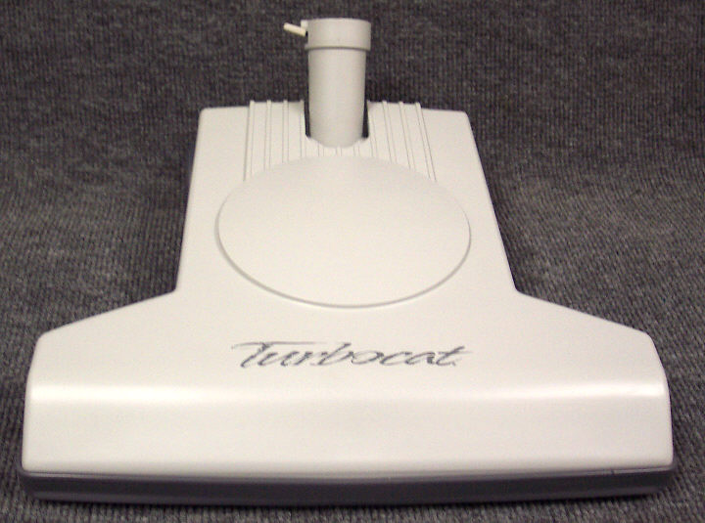

PU917BB

Brush Bearing Hydrovac

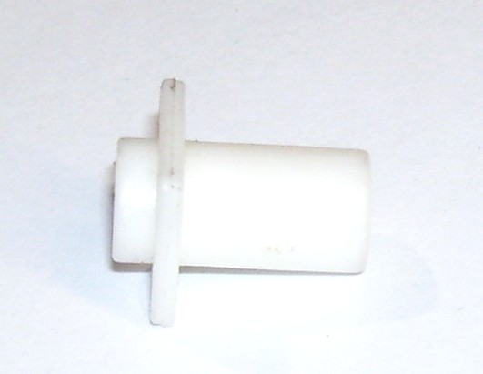

PU917BC

Turbine Bearing Complete Hydrovac

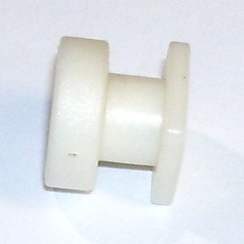

PU917TC

Turbine – Complete

Hydrovac

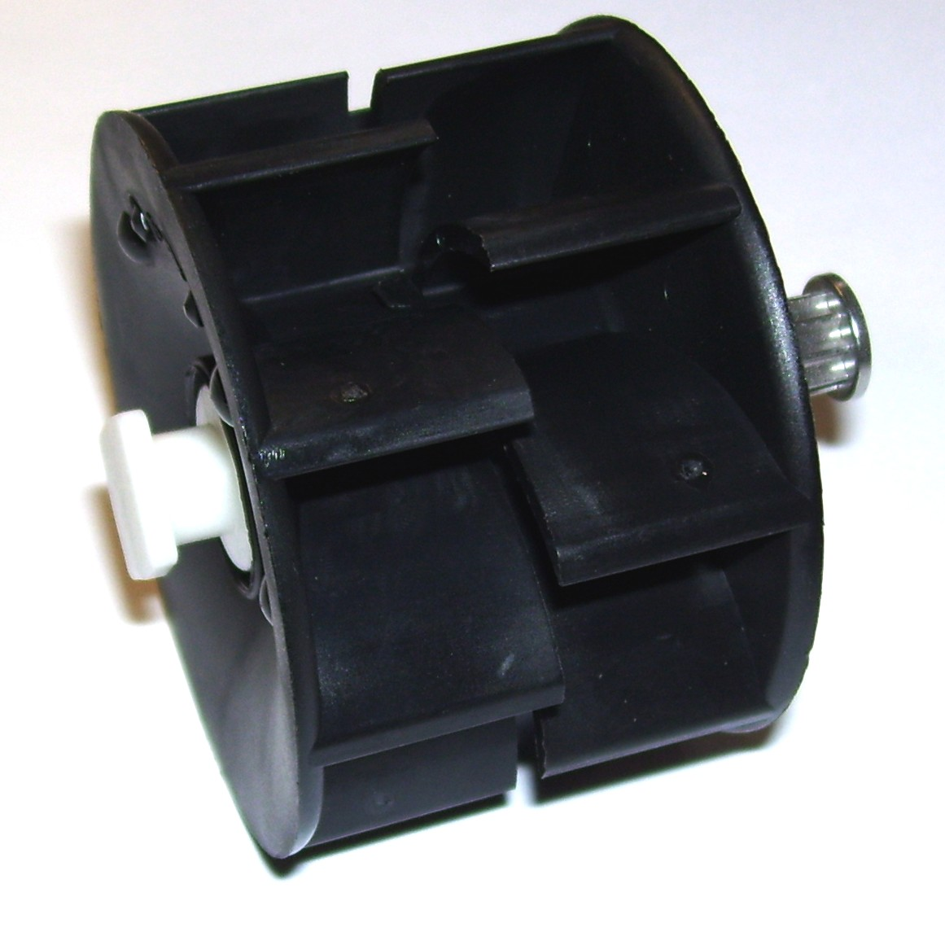

PU917SC

Suction Channel – Black

Hydrovac

